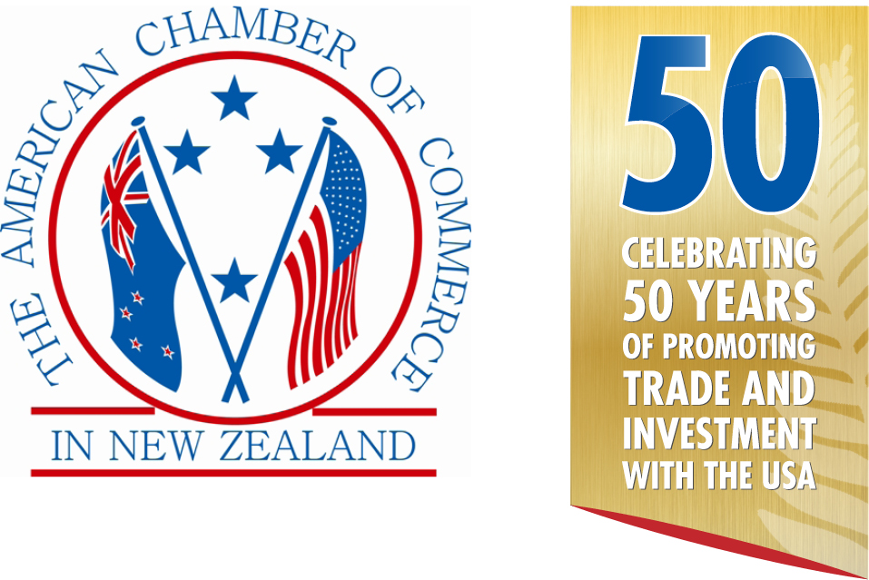
&



in conjunction with

Presents
THE AMCHAM–DHL Express
2017 ANNUAL AWARDS
CELEBRATING SUCCESS & INNOVATION

Silver Sponsors |  | Media Partner
 | 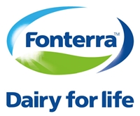 | 
 |  | Bronze Sponsor  

AMCHAM SUCCESS & INNOVATION AWARDS

In 2000 the American Chamber of Commerce in New Zealand introduced these Awards to celebrate success and innovation in business relationships with the USA. This event has now become a highlight of our year and with trade between the two countries continuing to expand, we expect even more interest in these Awards.

The American Chamber of Commerce in New Zealand and DHL Express are pleased announce the launch of the 2017 Awards in conjunction with United Airlines.

THE CATEGORIES & PRIZES

1. IMPORTER OF THE YEAR FROM THE USA
The winner receives an Economy Plus® Round Trip Ticket to the USA from United Airlines

2. EXPORTER OF THE YEAR TO THE USA — NZ$0 to NZ$1 Million
The winner receives an Economy Plus® Round Trip Ticket to the USA from United Airlines

3. EXPORTER OF THE YEAR TO THE USA — NZ$1 Million to NZ$10 Million
The winner receives an Economy Plus® Round Trip Ticket to the USA from United Airlines

4. EXPORTER OF THE YEAR TO THE USA — Over NZ$10 Million
The winner receives an Economy Plus® Round Trip Ticket to the USA from United Airlines

There will be 3 other awards with the winners being chosen by appointed judges. These will be:-

5. BILATERAL SERVICE AWARD
This award is for a person, group, or organization that has made significant contributions to strengthening ties between New Zealand and the United States. The contributions can have been made in any field that complements the deep political and economic ties between the two countries including education, science, research, culture, arts, sports and other sectors.
The winner will receive an Economy Plus® Round Trip Ticket to the USA from United Airlines

6. CONTRIBUTION TO TOURISM WITH THE USA

7. INVESTOR OF THE YEAR TO OR FROM THE USA

One of the above winners will be selected to be the overall Supreme Award Winner.

8. AMCHAM SUPORTER OF THE YEAR

THE JUDGES:

STEPHEN TITTER, Director, Hahei Consulting Ltd
SUE IRONSIDE, Partner, Baldwins
ALEX BROUGHTON, Partner, Business IQ Ltd
MATTHEW ENSOR, Business Director – Advisory Services, Beca Ltd
CHRIS CHANDLER, Head of Business Development, KPMG
JULIE REID, Director Australia & New Zealand, United Airlines

HOW DOES THE PROCESS WORK?

1. 1 April entries open
2. 31 May entries close
3. 3 July finalists announced
4. 3 August Success & Innovation Awards black tie dinner in Auckland

Finalists from outside Auckland are responsible for their own travel and accommodation costs and arrangements to attend the Awards dinner.

DOES MY BUSINESS QUALIFY?

Your business is eligible to enter if you have traded goods, or provided services, education, intellectual property, royalties, etc. to or from the USA during the last 12 months from 1 June 2016. You do not have to be an AmCham member.

HOW DO I ENTER?

- Choose a category that best suits your business.
- Complete this official entry form
- Provide the required information under each headings provided.
- Your entry should be Arial font, size 11 or greater and not be more than 6 A4 pages.
- All applications should be emailed to awards@amcham.co.nz by 5.00pm 31st May 2017.
- All finalists will then be contacted to arrange a time to meet with the judges for an in depth question session, either face to face or via video/Skype.

The winners will be announced at a gala dinner ceremony on 3rd August 2017. Tickets cost $235.00 (inc GST) each. Finalists from outside Auckland are responsible for their own travel and accommodation costs and arrangements to attend the Awards dinner.

If you have any questions please contact: Mike Hearn
Executive Director
American Chamber of Commerce in New Zealand Inc.
Tel: 09-309-9140
Mob: 021-707-506
Email: mike@amcham.co.nz

THE CRITERIA

The Judges will be looking for and evaluating the best examples of a passion for business success, a commitment to innovation, a demonstrated approach to developing marketing opportunities and a demonstrated commitment to corporate citizenship.

For the Bilateral Services Award you will be required to submit a two page submission outlining the significant contributions you have made to strengthening ties between New Zealand and the United States. The contributions can have been made in any field that complements the deep political and economic ties between the two countries including education, science, research, culture, arts, sports and other sectors. Please provide as much information as you can that will give the judges a clear picture of your contributions.

Companies entering the competition are not expected to submit any details or data which would be considered proprietary in nature, however we do require key information on which to make our assessments ensures appropriate winners are determined and are prepared to sign confidentiality agreements with any entrant.

The small print

- Your entry (except for the announcement of the company name as finalist and/or winner) will remain confidential.
- The judge’s decision is final. No correspondence will be entered into.
- Judges are required to disclose any conflict of interest and will be excluded from the judging process where conflicts arise.
- AmCham accepts no responsibility for your entry or any supporting material sent in with your entry and cannot guarantee their return.
- The international travel prizes must be used by 31 July 2018.
- Winners are responsible for any travel costs to Auckland or Christchurch, all taxes in New Zealand and the USA, accommodation costs in the USA and any other costs incurred.
- Travel on United Airlines is subject to space being available when reservations are made.
- Travel does not qualify for frequent flyer points
- Winners may be given the opportunity of providing a presentation on their company at an AmCham function to be held later in the year following the Awards dinner.
- Winners agree to provide media partner interviews.

OFFICIAL ENTRY FORM

Full and correct name of entrant

Postal address

Telephone

Mobile

Email

Website

Contact Person

Title

Category entered:

1. Importer of the Year

2. Exporter of the Year NZ$0 to NZ$1 million

3. Exporter of the Year NZ$1 million to NZ$10 million

4. Exporter of the Year over NZ$10 million

5. Investor of the Year

6. Bilateral Services Award

7. Contribution to Tourism

Bilateral Services Award
Please outline the significant contributions you have made to strengthening ties between New Zealand and the United States. (Maximum two pages)

Final comments
If there are any additional comments you would like to make regarding your award entry, (e.g. explanatory notes to the judges, links to online videos, publications or files referred to earlier) please include them here.

