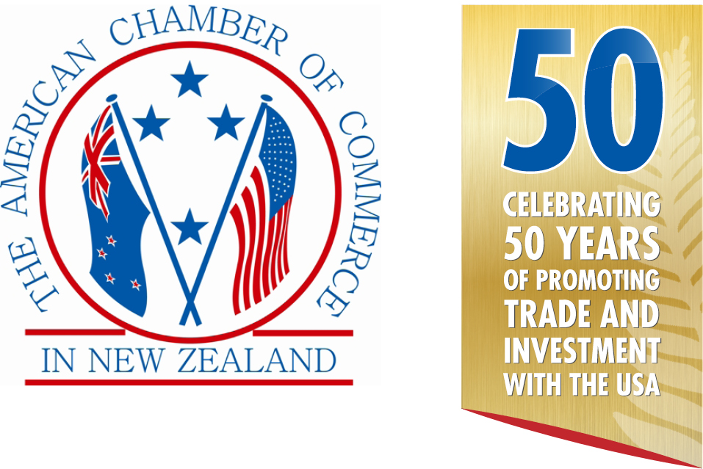
&


in conjunction with

Presents
THE AMCHAM–DHL Express
2019 ANNUAL AWARDS
CELEBRATING SUCCESS & INNOVATION

Silver Sponsors |  | Media Partner
 |  | 
 |  | Bronze Sponsor  

AMCHAM SUCCESS & INNOVATION AWARDS

In 2000 the American Chamber of Commerce in New Zealand introduced these Awards to celebrate success and innovation in business relationships with the USA. This event has now become a highlight of our year and with trade between the two countries continuing to expand, we expect even more interest in these Awards.

The American Chamber of Commerce in New Zealand and DHL Express are pleased announce the launch of the 2019 Awards in conjunction with Hawaiian Airlines.

THE CATEGORIES & PRIZES

1. IMPORTER OF THE YEAR FROM THE USA
The winner receives an Economy Plus® Round Trip Ticket to the USA from United Airlines

2. EXPORTER OF THE YEAR TO THE USA — NZ$0 to NZ$1 Million
The winner receives an Economy Plus® Round Trip Ticket to the USA from United Airlines

3. EXPORTER OF THE YEAR TO THE USA — NZ$1 Million to NZ$10 Million
The winner receives an Economy Plus® Round Trip Ticket to the USA from United Airlines

4. EXPORTER OF THE YEAR TO THE USA — Over NZ$10 Million
The winner receives an Economy Plus® Round Trip Ticket to the USA from United Airlines

5. BILATERAL CONNECTIONS AWARD
This award is for a person, group, or organization that has made significant contributions to strengthening ties between New Zealand and the United States. The contributions can have been made in any field that complements the deep political and economic ties between the two countries including education, science, research, culture, arts, sports and other sectors.
The winner will receive an Economy Plus® Round Trip Ticket to the USA from United Airlines

6. CONTRIBUTION TO TOURISM WITH THE USA
To recognize the passion and dedication that a tourism entity has contributed to the growth of travel & tourism between New Zealand and the USA or vice versa.
This award is given to a tourism entity or organization that has given valuable contribution and shown innovation, creativity and uniqueness resulting in increased awareness & visitation of tourists between New Zealand and the USA or vice versa.
The winner receives an Economy Plus® Round Trip Ticket to the USA from United Airlines

7. INVESTOR OF THE YEAR TO OR FROM THE USA

8. BILATERAL ENTREPRENEUR/INNOVATOR OF THE YEAR WITH THE USA
One of the above winners will be selected to be the overall Supreme Award Winner.

9. AMCHAM SUPORTER OF THE YEAR

THE JUDGES:

GAVIN HAWORTH, Head of Transaction Banking Commercial & Agri NZ, ANZ Bank
MATTHEW ENSOR, Business Director – Advisory Services, Beca Ltd
HAL JOSEPHSON, President, MediaSence Inc.
JO ALLISON, Chief Operating Officer, Tourism Holdings Ltd
MIKE RILEY, Principal, StrategyNZ
JONATHAN REID, Executive Chairman & Co-Founder, VMG Ventures & Goat Ventures
JULIE REID, Director Australia & New Zealand, United Airlines
TONY EATON, Managing Director, US Global Tax Ltd

HOW DOES THE PROCESS WORK?

1. 1 April entries open
2. 31 May entries close
3. 3 July finalists announced
4. 22 August Success & Innovation Awards black tie dinner in Auckland

DOES MY BUSINESS QUALIFY?

Your business is eligible to enter if you have traded goods, or provided services, education, intellectual property, royalties, etc. to or from the USA during the last 12 months from 1 June 2018. You do not have to be an AmCham member.

HOW DO I ENTER?

- Choose a category that best suits your business.
- Complete this official entry form
- Provide the required information under each headings provided.
- Your entry should be Arial font, size 11 or greater and not be more than 6 A4 pages.
- All applications should be emailed to awards@amcham.co.nz by 5.00pm 31st May 2019.
- All finalists will then be contacted to arrange a time to meet with the judges for an in depth question session, either face to face or via video/Skype.

The winners will be announced at a gala dinner ceremony on 22nd August 2019. Tickets cost $250.00 (inc GST) each. Finalists from outside Auckland are responsible for their own travel and accommodation costs and arrangements to attend the Awards dinner.

If you have any questions please contact: Mike Hearn
Executive Director
American Chamber of Commerce in New Zealand Inc.
Tel: 09-309-9140
Mob: 021-707-506
Email: mike@amcham.co.nz

THE CRITERIA

The Judges will be looking for and evaluating the best examples of a passion for business success, a commitment to innovation, a demonstrated approach to developing marketing opportunities and a demonstrated commitment to corporate citizenship.

The judges will be looking for the following key information in your application:
- Business operations summary
- Financial (track record and projections)
- Commitment to innovation
- Marketing and business sales strategies
- Corporate citizenship

Please ensure your application reflects these weightings and give priority to the appropriate sections. Your entry is not permitted to be more than 6 A4 pages and must be Arial font size 11 or greater.

Companies entering the competition are not expected to submit any details or data which would be considered proprietary in nature, however we do require key information on which to make our assessments ensures appropriate winners are determined and are prepared to sign confidentiality agreements with any entrant.

To the extent possible, it would be helpful to convey the financial health, general magnitude of the export or import sales volume; the resultant employment generation in New Zealand or the United States: - and, other factors which might describe the corporate citizenship roles of the firm.

The small print

- Your entry (except for the announcement of the company name as finalist and/or winner) will remain confidential.
- The judge’s decision is final. No correspondence will be entered into.
- Judges are required to disclose any conflict of interest and will be excluded from the judging process where conflicts arise.
- AmCham accepts no responsibility for your entry or any supporting material sent in with your entry and cannot guarantee their return.
- The international travel prizes must be used by 31 July 2020.
- Winners are responsible for any travel costs to Auckland or Christchurch, all taxes in New Zealand and the USA, accommodation costs in the USA and any other costs incurred.
- Travel on United Airlines is subject to space being available when reservations are made.
- Travel does not qualify for frequent flyer points
- Winners may be given the opportunity of providing a presentation on their company at an AmCham function to be held later in the year following the Awards dinner.
- Winners agree to provide media partner interviews.

OFFICIAL ENTRY FORM

Full and correct name of entrant

Postal address

Telephone

Mobile

Email

Website

Contact Person

Title

Category entered:

Importer of the Year

Exporter of the Year NZ$0 to NZ$1 million

Exporter of the Year NZ$1 million to NZ$10 million

Exporter of the Year over NZ$10 million

Investor of the Year

Bilateral Connections Award

Contribution to Tourism

Bilateral Entrepreneur/Innovator of the Year

Business operations summary
Please provide a precise description of your company’s value proposition, business operations including the target market and industry sector in which you compete.

Financial (track record and projections)
Please provide general results of trading and business operations which clearly show your success (including sales and profitability/solvency statement) within the New Zealand marketplace for the last 3 to 5 years and also projections for the next 1-2 years.

What are the current levels and trends in key measures and/or indicators of financial performance, including aggregate measures of financial return and or economic value, as appropriate?

What are the current levels and trends in key business measures and/or indicators of marketplace performance, including market share/position, business growth and new markets entered, as appropriate?

Commitment to innovation
Please identify specific initiatives your company has taken that stand out in your field as truly innovative and give examples of how this innovation has translated into customer benefit and business success.

How does the company search for new product/process innovation?

How does the company assess an opportunity to innovate?

How does the company implement and pursue innovation opportunities?

Does this innovation change the rules of play that the organisation is involved in?

Is innovative thinking embedded into the culture of the organisation?

Is innovation a one off or is it a repeatable exercise in this organisation?

Marketing and business sales strategies
Please outline your company’s Marketing & Sales Strategies and how these have led to business successes within the New Zealand marketplace.

How does the company determine or target customers, customer groups and/or market segments?

How does the company listen & learn to determine key needs & drivers of purchase decisions for current, former & potential customers?

How does the company determine and/or project key product/service features and their relative importance/value to customers for the purposes of current and future marketing, product planning, and other business developments?

What process, measurement methods, and data do you use to determine customer satisfaction and dissatisfaction?

How do you follow up with customers on products/services & recent transactions to receive prompt & actionable feedback?

How do you obtain and use information on customer satisfaction relative to competitors and/or benchmarks?

Commitment to sustainability and social impact
Commitment to sustainability and social impact - Locally, what corporate citizenship initiatives are you involved with? What impact do they have on your business? Please describe exactly what your involvement is and what you get in return. Please be as specific as possible.

How do you address the impacts on society of your products, services and operations?

How do you anticipate and address public concerns with current and future products, services and operations?

How does the organisation, your senior leaders, and your employees actively support and strengthen your key communities?

How do you seek input from employees and their supervisors/managers on educational and training needs, expectations and design?

How do you enhance your employees work climate via health and safety practices, services, benefits and policies?

How do you determine key factors that affect employee well being, satisfaction and motivation?

Final comments
If there are any additional comments you would like to make regarding your award entry, (e.g. explanatory notes to the judges, links to online videos, publications or files referred to earlier) please include them here.

