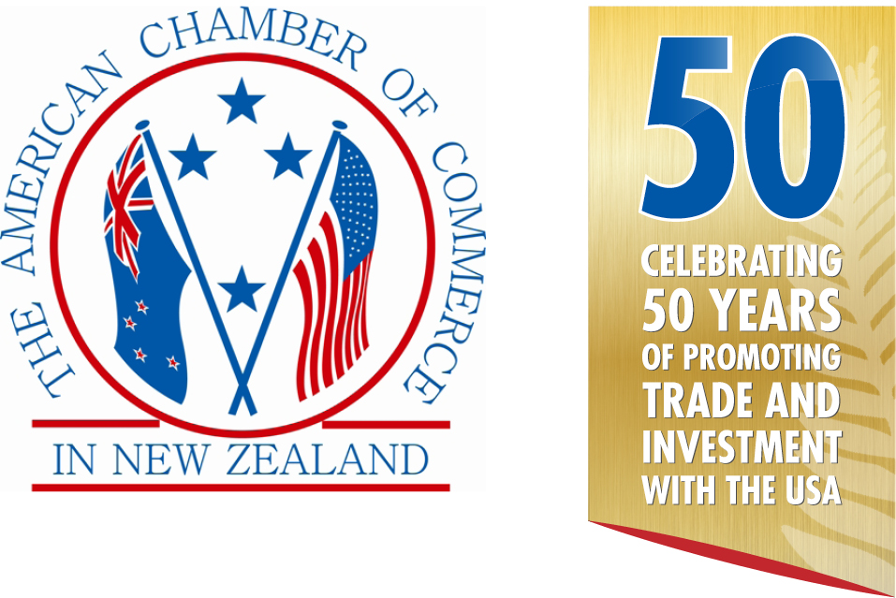
&



in conjunction with

Presents
THE AMCHAM–DHL Express
2017 ANNUAL AWARDS
CELEBRATING SUCCESS & INNOVATION

Silver Sponsors |  | Media Partner
 | 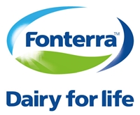 | 
 |  | Bronze Sponsor  

AMCHAM SUCCESS & INNOVATION AWARDS

In 2000 the American Chamber of Commerce in New Zealand introduced these Awards to celebrate success and innovation in business relationships with the USA. This event has now become a highlight of our year and with trade between the two countries continuing to expand, we expect even more interest in these Awards.

The American Chamber of Commerce in New Zealand and DHL Express are pleased announce the launch of the 2017 Awards in conjunction with Hawaiian Airlines.

THE CATEGORIES & PRIZES

1. IMPORTER OF THE YEAR FROM THE USA
The winner receives an Economy Plus® Round Trip Ticket to the USA from United Airlines

2. EXPORTER OF THE YEAR TO THE USA — NZ$0 to NZ$1 Million
The winner receives an Economy Plus® Round Trip Ticket to the USA from United Airlines

3. EXPORTER OF THE YEAR TO THE USA — NZ$1 Million to NZ$10 Million
The winner receives an Economy Plus® Round Trip Ticket to the USA from United Airlines

4. EXPORTER OF THE YEAR TO THE USA — Over NZ$10 Million
The winner receives an Economy Plus® Round Trip Ticket to the USA from United Airlines

There will be 3 other awards with the winners being chosen by appointed judges. These will be:-

5. BILATERAL SERVICE AWARD
This award is for a person, group, or organization that has made significant contributions to strengthening ties between New Zealand and the United States. The contributions can have been made in any field that complements the deep political and economic ties between the two countries including education, science, research, culture, arts, sports and other sectors.
The winner will receive an Economy Plus® Round Trip Ticket to the USA from United Airlines

6. CONTRIBUTION TO TOURISM WITH THE USA
To recognize the passion and dedication that a tourism entity has contributed to the growth of travel & tourism between New Zealand and the USA or vice versa.
This award is given to a tourism entity or organization that has given valuable contribution and shown innovation, creativity and uniqueness resulting in increased awareness & visitation of tourists between New Zealand and the USA or vice versa.

7. INVESTOR OF THE YEAR TO OR FROM THE USA

One of the above winners will be selected to be the overall Supreme Award Winner.

8. AMCHAM SUPORTER OF THE YEAR

THE JUDGES:

STEPHEN TITTER, Director, Hahei Consulting Ltd
SUE IRONSIDE, Partner, Baldwins
ALEX BROUGHTON, Partner, Business IQ Ltd
MATTHEW ENSOR, Business Director – Advisory Services, Beca Ltd
CHRIS CHANDLER, Head of Business Development, KPMG
JULIE REID, Director Australia & New Zealand, United Airlines

HOW DOES THE PROCESS WORK?

1. 1 April entries open
2. 31 May entries close
3. 3 July finalists announced
4. 3 August Success & Innovation Awards black tie dinner in Auckland

DOES MY BUSINESS QUALIFY?

Your business is eligible to enter if you have traded goods, or provided services, education, intellectual property, royalties, etc. to or from the USA during the last 12 months from 1 June 2016. You do not have to be an AmCham member.

HOW DO I ENTER?

- Choose a category that best suits your business.
- Complete this official entry form
- Provide the required information under each headings provided.
- Your entry should be Arial font, size 11 or greater and not be more than 6 A4 pages.
- All applications should be emailed to awards@amcham.co.nz by 5.00pm 31st May 2017.
- All finalists will then be contacted to arrange a time to meet with the judges for an in depth question session, either face to face or via video/Skype.

The winners will be announced at a gala dinner ceremony on 3rd August 2017. Tickets cost $235.00 (inc GST) each. Finalists from outside Auckland are responsible for their own travel and accommodation costs and arrangements to attend the Awards dinner.

If you have any questions please contact: Mike Hearn
Executive Director
American Chamber of Commerce in New Zealand Inc.
Tel: 09-309-9140
Mob: 021-707-506
Email: mike@amcham.co.nz

THE CRITERIA

The Judges will be looking for and evaluating the best examples of a passion for business success, a commitment to innovation, a demonstrated approach to developing marketing opportunities and a demonstrated commitment to corporate citizenship.

In judging the entries, the weightings allocated by the judges will be as follows:
- Business operations summary 5%
- Financial (track record and projections) 35%
- Commitment to innovation 25%
- Marketing and business sales strategies 30%
- Corporate citizenship 5%

Please ensure your application reflects these weightings and give priority to the appropriate sections. Your entry is not permitted to be more than 6 A4 pages and must be Arial font size 11 or greater.

Companies entering the competition are not expected to submit any details or data which would be considered proprietary in nature, however we do require key information on which to make our assessments ensures appropriate winners are determined and are prepared to sign confidentiality agreements with any entrant.

To the extent possible, it would be helpful to convey the financial health, general magnitude of the export or import sales volume; the resultant employment generation in New Zealand or the United States: - and, other factors which might describe the corporate citizenship roles of the firm.

The small print

- Your entry (except for the announcement of the company name as finalist and/or winner) will remain confidential.
- The judge’s decision is final. No correspondence will be entered into.
- Judges are required to disclose any conflict of interest and will be excluded from the judging process where conflicts arise.
- AmCham accepts no responsibility for your entry or any supporting material sent in with your entry and cannot guarantee their return.
- The international travel prizes must be used by 31 July 2018.
- Winners are responsible for any travel costs to Auckland or Christchurch, all taxes in New Zealand and the USA, accommodation costs in the USA and any other costs incurred.
- Travel on Hawaiian Airlines is subject to space being available when reservations are made.
- Travel does not qualify for frequent flyer points
- Winners may be given the opportunity of providing a presentation on their company at an AmCham function to be held later in the year following the Awards dinner.
- Winners agree to provide media partner interviews.

OFFICIAL ENTRY FORM

Full and correct name of entrant

Postal address

Telephone

Mobile

Email

Website

Contact Person

Title

Category entered:

1. Importer of the Year

2. Exporter of the Year NZ$0 to NZ$1 million

3. Exporter of the Year NZ$1 million to NZ$10 million

4. Exporter of the Year over NZ$10 million

5. Investor of the Year

6. Bilateral Services Award

7. Contribution to Tourism

Business operations summary (5%)
Please provide a precise description of your company’s value proposition, business operations including the target market and industry sector in which you compete.

Financial (track record and projections) (35%)
Please provide general results of trading and business operations which clearly show your success (including sales and profitability/solvency statement) within the New Zealand marketplace for the last 3 to 5 years and also projections for the next 1-2 years.

Commitment to innovation (25%)
Please identify specific initiatives your company has taken that stand out in your field as truly innovative and give examples of how this innovation has translated into customer benefit and business success.

Marketing and business sales strategies (30%)
Please outline your company’s Marketing & Sales Strategies and how these have led to business successes within the New Zealand marketplace.

Corporate citizenship (5%)
Please outline how your company has demonstrated a commitment to corporate citizenship (aligned to community need and interests) through contributing to community needs and interests.

Final comments
If there are any additional comments you would like to make regarding your award entry, (e.g. explanatory notes to the judges, links to online videos, publications or files referred to earlier) please include them here.

